PARKINSON'S POST.

Chester & District Branch.
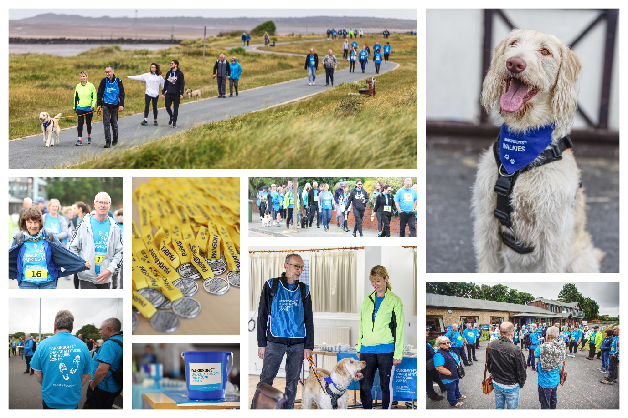
June 2022
Facebook: Parkinson’s UK – Chester District Branch
Twitter: @Parkinson’s Chester
Website: chesterparkinsons.weebly.com

Contents.
1. Photograph by ‘idreamofpiesphotography’, walk for Parkinson’s Crosby June 2022
2. Contents
3. Nick’s Notes
4. Movers Shakers
5. Photographs – Movers Shakers, Alison Richard Zoom
6. Drop in Café, Chester
7. July Coffee Morning, Tarporley.
8/9. Nurse Advice Line
10. New Committee Members
11. Parkinson’s Walking Football
12. Parkinson’s UK
13. Exercise Opportunities
14. Pam’s Zoom chat.
15-16. Billy Connolly (and Bart Simpson)
17. PAR for Parkinson’s
18. 5 Facts About Parkinson’s
19. London Underground
20. Keeping in Contact / Text Message Service
21. Counselling at The NTC
22. Events and Information
23/24. AbilityNet
25. DBS
26. Incurable Optimists
27. Crewe Branch Drop in Café
28/29. Branch Policy and other contacts
30. Spring Lunch Pictures
31. Walk For Parkinson’s Shrewsbury
32. Contacts
Nick’s Notes.
Watching the thousands of people at the celebrations for the Queen’s Platinum Jubilee and at the same time seeing the enormous number of passengers at the airports rushing to get away on holiday, certainly gives me the impression that the country is well on the road to recovering from the pandemic. I like to think that this is also the case within our Chester Branch. Since the last edition of the Parkinson’s Post, we have held a very successful and enjoyable Christmas Lunch at the Pryors Hayes Golf Club and recently our Spring Lunch with AGM at Rowton Hall Hotel together with a couple of coffee mornings. These events were well attended and has given the Committee the confidence to introduce more events during the rest of the year. Details are included in this edition. Without trying to describe everything, I would just like to draw your attention to the Drop in Cafe at the United Reform Church in Hoole, Chester. We hope this will become a regular monthly meeting place for members to meet and discuss anything and everything over a drink and a cake. I made the sacrifice together with other members of the Committee to check out the venue and to make sure the cakes were up to scratch! I can report the atmosphere was most welcoming, access and parking is excellent and the cakes came through with flying colours. As I said earlier you can find details in this magazine.
As a committee we are well aware of the difficulties and heartache many of us have been through in the last couple of years and therefore we will take a balanced approach to our programmes going forward. In addition to the social activities I have already mentioned, we will continue to signpost you to relevant activities and other support groups which are available and offer help to our members. Pam will be continuing with her very successful weekly and monthly zoom meetings. We are however, well aware of the need to proceed with care and attention to members needs and feelings so we will constantly measure feedback and attendance levels, to ensure we are truly reflecting the wishes and needs of the Branch
Having dealt with the positive issues I need to come back to perhaps a more important issue which is something I mentioned last time. It is vitally important that we ensure the strength of the Committee is maintained going forward, hence I would ask you all to read the article in this copy of the Post regarding New Committee Members. Any help or ideas will be most welcome and even the smallest offer of support may be just enough for us to carry on in the way we have been operating in recent years. Finally, on behalf of the Committee, I would like to wish you all an enjoyable summer.
Nick.

Parkinson’s UK – Chester & District Branch
“Movers Shakers”
Therapeutic singing group

St Columba’s Church Hall, Plas Newton Lane
Chester CH2 1PL
Fridays 1pm – 2.30pm

Come along and sing your much loved favourites and learn some exciting new pieces
Plenty of parking space
Tea, coffee & biscuits
EVERYONE WELCOME
(with or without Parkinson’s)
BRING A FRIEND
No charge, donation asked for refreshments.
Movers Shakers

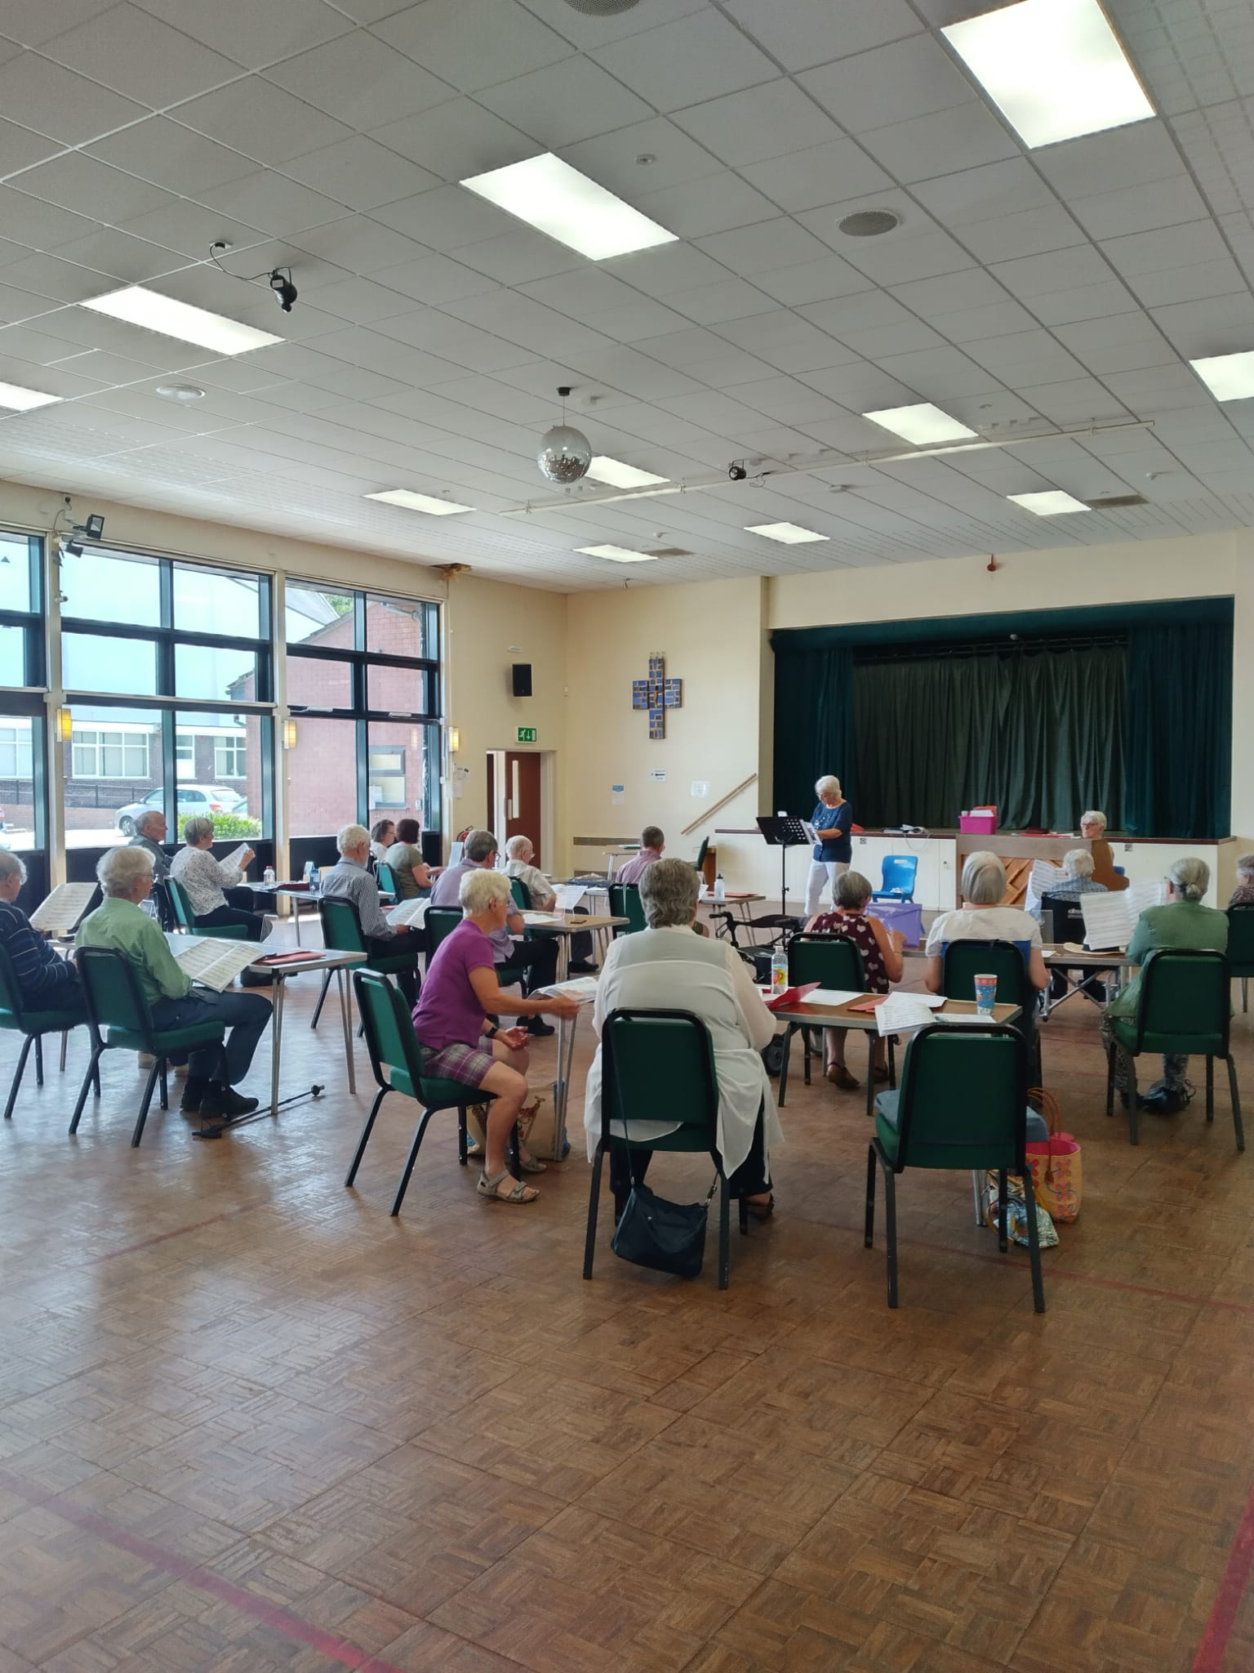

Alison Richards Zoom

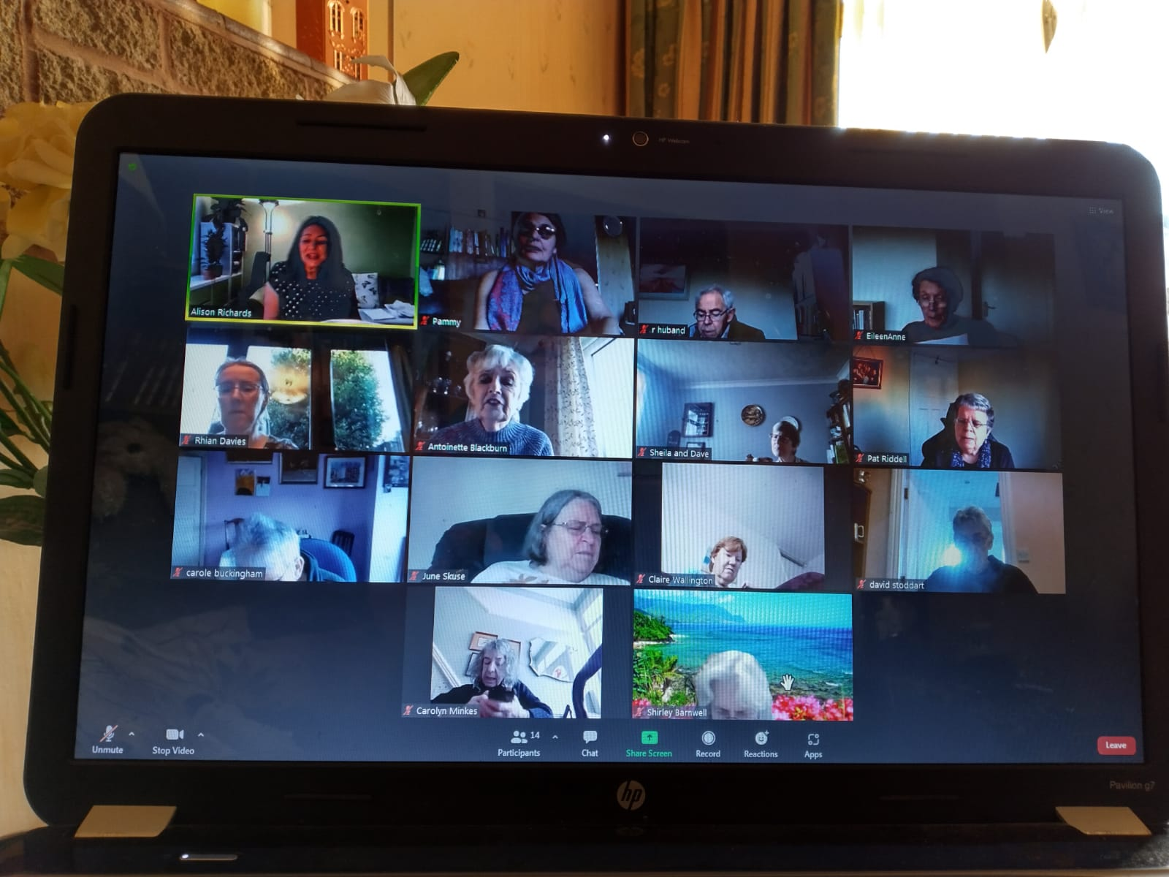
Parkinson’s UK – Chester & District Branch
Are you or anyone you know affected by Parkinson’s? Would you like to meet others for a chat? You will receive a warm welcome.
DROP IN CAFÉ
Thursday 16th June and every 3rd Thursday of each month thereafter.
2.30pm – 4pm
Hoole United Reformed Church,
Hoole Road, Hoole,
Chester, CH2 3NT
Excellent parking – please note the one-way system
The United Reformed Church has kindly allowed us to join their monthly event “Cake & Church”, to enable people with Parkinson’s and their family/friends/carers to meet, chat and have tea/coffee and cake in a relaxed atmosphere. There is also a book table – just bring along any you’ve read and take some new ones.
For more information about the above please contact alistairtranter@btinternet.com
Our Website: http://chesterparkinsons.weebly.com/
We are on Facebook: https://www.facebook.com/ParkinsonsCh/

Need advice about your Parkinson’s? Call the Parkinson’s UK Helpline 0808 800 0303

Parkinson’s UK – Chester & District Branch

Come and join us for morning coffee in Tarporley

Thursday 14th July at 11am
£8 each for Coffee /Tea with scones and preserves
MacDonald Portal Golf & Spa Hotel
Cobblers Cross Lane,
Tarporley
CW6 0DJ

Booking is required please by Monday 4th July
email paminchester@yahoo.co.uk
Or call 01244 376546
We look forward to seeing you.

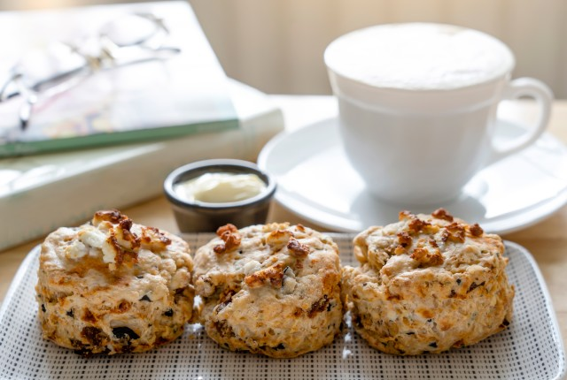

Nurse advice line • 0151 556 4008

Who is the service for?
The nurse advice line service is for patients with long-term neurological conditions under the care of The Walton Centre, their carers, relatives, GPs, other health care professionals, advocates and anyone involved in supporting them. It is also available to those patients accessing The Walton Centre’s Integrated Neurology Nurse Specialist service.

What is the criteria to use the service?
If you have the following conditions and are under the care of a Walton Centre Neurologist, you are eligible to use the service:
- Multiple Sclerosis
- Epilepsy
- Motor Neurone Disease
- Movement Disorder, e.g. essential tremor
- Parkinson’s Disease
- Neuromuscular Disease

What is the service?
The Nurse Advice Line is available to offer specialist advice, guidance and support to patients, their carers, relatives, GPs, other health care professionals, advocates and anyone involved in supporting them. It is not an emergency advice line. Access is via a telephone appointment service manned by an administrative co-ordinator who will arrange a nurse to call back with specialist advice on the following conditions: multiple sclerosis, epilepsy, motor neurone disease, movement disorder, Parkinson’s disease and neuromuscular disease.
This service may be useful for questions regarding medication and side effects; if patients’ condition deteriorates; if there are concerns about breathing, eating drinking or concerns over weight loss; an increase in seizures; and for signposting to other services and benefits advice.
Contact the Nurse Advice Line on 0151 556 4008

What happens when you call the service?
Patients, their carers, relatives, GPs, other health care professionals, advocates and anyone involved in supporting them can contact the Nurse Advice Line. One of our fully trained administrative co-ordinators will handle the call. Service users are asked for a brief outline as to the reason for the call. Certain non-clinical calls can be managed by our administrative coordinators without the need to book a specialist nurse call back. For calls requiring specialist nurse advice, the administrative co-ordinators will agree a suitable appointment date and time for the call back telephone consultation. You will be given the next available appointment.
Patients, their carers, relatives, GPs, other health care professionals, advocates and anyone involved in supporting them will receive:
- Access to the right level of specialist nurse care
- Advice and support regarding long term neurological conditions
- Signposting to other health care professionals if necessary
What the Nurse Advice Line does not do:
- Provide emergency advice
- Handle calls requiring urgent attention
- Diagnose patients
The Nurse Advice Line service is designed to help you receive the best possible care and support you in making the right decisions regarding your care.

New Committee Members

The Branch Committee, with an eye to the future, are looking to recruit new members to our ranks. It has been previously mentioned that Chris Knight stood down in April, and you may also remember that in the not too distant past, Tim Hollins moved away and understandably eventually retired from the Committee. It is important that we ensure the strength of the Committee is maintained going forward. Hence the decision to actively look for new members to join and bring new ideas and skills to the Committee.

We are asking for your help please. If anyone would like to find out more about being a member of the Committee, or knows of a family member, relative or friend who might be interested we would really love to hear from you. We are particularly looking to attract new members who can bolster our secretarial, minute taking and social media skills, but that said all volunteers are always welcome.

Membership of the Committee should be an enjoyable experience and nobody is put under any pressure to do more than they feel comfortable undertaking. We hold meetings once a month and since the pandemic began we have conducted the meeting on Zoom. Using Zoom has proved so beneficial that we have taken the decision to continue in this way going forward.

If you are interested in helping the Branch and wish to find out more information please contact Nick Dent on 01244 301378 or Alistair Tranter on 01244 311402.

Many Thanks. The Committee
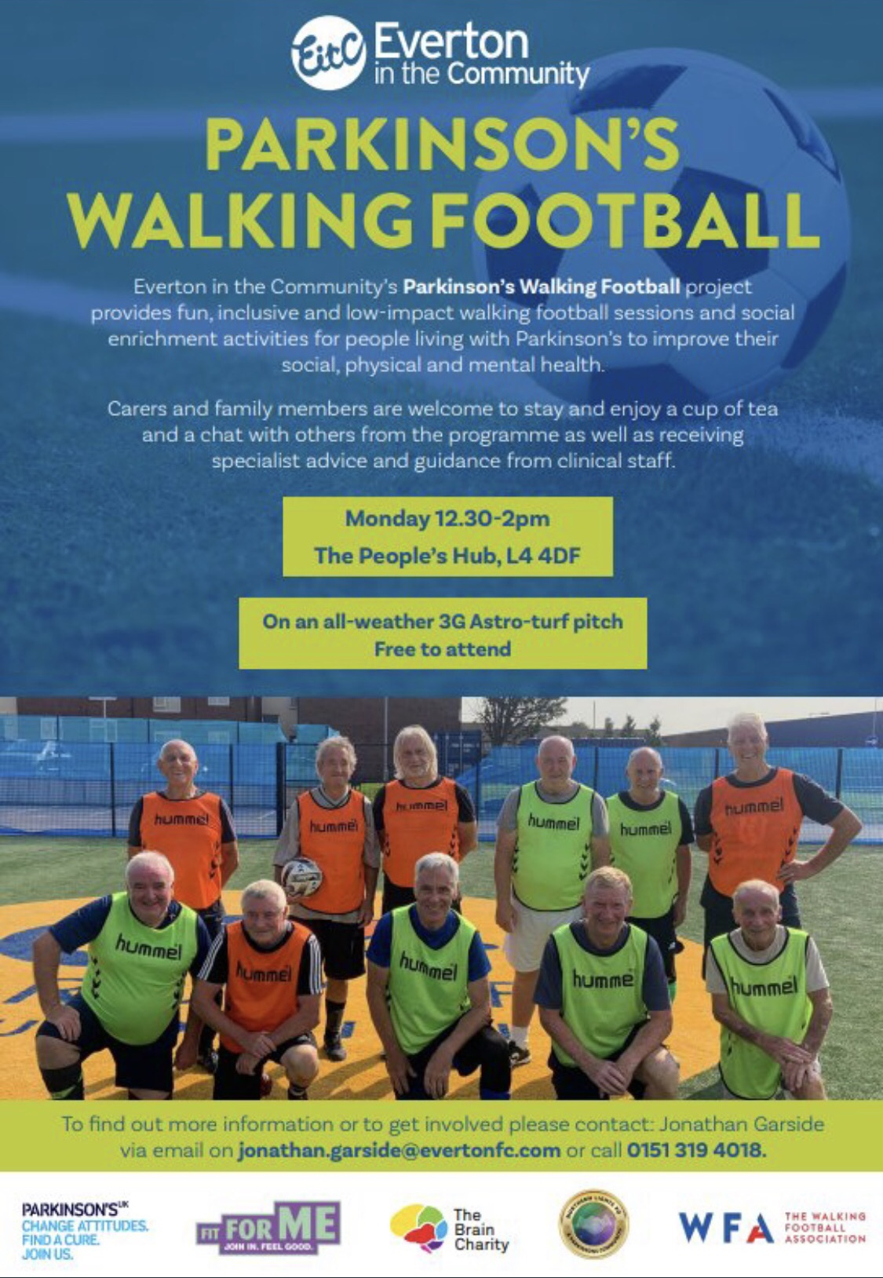

Parkinson's UK is here to provide information and support to anyone affected by the condition.

Our helpline is a free, confidential service. Trained Advisers, including Parkinson's Nurse Advisers, Benefit and Employment Advisers and a Care Adviser, provide information about all aspects of living with the condition, including:
- medical issues, including symptoms and treatments
- emotional support
- health and social care
- local activities
- employment and benefits
- signposting to other sources of information
Helpline Advisers can put you in touch with a Parkinson's Adviser in your local area if more local or in depth information and support is needed.

Parkinson's Local Advisers have a wide range of knowledge and expertise about Parkinson’s and can help if someone:
- has been newly diagnosed and is looking for advice and information
- is looking for tips on how to deal with the day to day impact of Parkinson's
- would like to find out about services in their local area, including health services, such as Parkinson's Nurse Specialists and Physiotherapy and how to access them
- has a friend or family member who needs support
- needs emotional support
- wants to learn about their rights and entitlements
- needs help navigating the benefits process
- needs support with anything else relating to life with Parkinson's
The free helpline is open:
Monday to Friday - 9 am-6pm
Saturday - 10 am-2 pm
Please call: 0808 800 0303
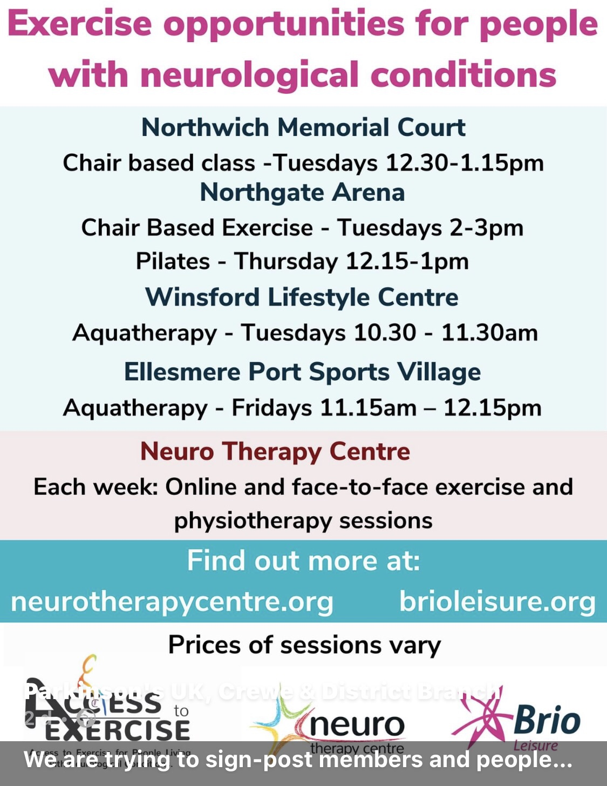

Zoom chat and quizzes
This takes place on Zoom every Thursday from 5pm and has turned out to be very successful – and great fun!!

Why not pop in???
Please contact me if you would like to join in:

paminchester@yahoo.co.uk

BAFTA TV AWARDS 2022

A fighter, a gentleman and a funny man, Sir Billy Connolly insists 'life is beautiful' despite Parkinson's battle as the frail star wins praise from fans while accepting fellowship gong.
Emotional viewers have praised Sir Billy Connolly for his 'beautiful' acceptance speech at the BAFTA TV Awards as he was honoured with the fellowship gong. The Scottish comedian, 79, was celebrated for a career spanning more than five decades at the Virgin Media Bafta TV Awards at London's Royal Festival Hall earlier this year.

The fellowship is the highest accolade given by The Academy to recognise 'outstanding and exceptional contribution' in film, games or television across their career. Viewers were left teary-eyed after Sir Billy, also known as The Big Yin, appeared in a pre-recorded message from his US home and spoke about his Parkinson's disease as he accepted the honour.
Sir Billy, who was knighted in 2017 for services to entertainment and charity, was diagnosed with Parkinson's in 2013 and retired from live performances five years later but has continued to record programmes and make TV appearances. He said: 'I went from strength to strength on television and here we are today, getting this award.
Sir Billy, who is set to turn 80 this year, previously spoke to Bafta.org about receiving the prestigious fellowship. He said: 'I have a collection of shiny things that I'm very proud of. But I never set out to get them or hunt them down. I don't believe in aiming at it because if you don't get it for whatever reason you're all disappointed.
Sir Billy joins a prestigious list of other recipients honoured for their work in the world of television which includes Sir David Attenborough, Dame Julie Walters, Sir Trevor McDonald, Dame Joanna Lumley, Dawn French, Jennifer Saunders, Jon Snow, Sir Bruce Forsyth, Dame Joan Bakewell and others.
Born in Glasgow in 1942, Sir Billy began his working life as a welder in the Clyde shipyards before embarking on a career as a folk singer and musician alongside Gerry Rafferty in The Humblebums before developing the stand-up act that made him famous. He is also an accomplished actor, winning praise for his role opposite Dame Judi Dench in Mrs Brown in 1997, as well as The Man Who Sued God and The Hobbit: The Battle Of The Five Armies. He is also a gifted travel reporter, making a string of popular documentaries.
In 2002, Sir Billy was presented with a Bafta Special Award and made a CBE in the 2003 Queen's Birthday Honours List. Two years later, he was honoured with a lifetime achievement award by Bafta Scotland for six decades in showbusiness. Receiving the fellowship this year means Sir Billy is being recognised by Bafta for the third successive decade.
He added of the fellowship: 'I am deeply honoured. Fifty films and I can't remember how many TV shows - as well as my stage comedy - added up to something that's a joy to look back on. A lovely thing. I have no regrets at all’. He credited the first of many appearances on Michael Parkinson's chat show in 1975 with helping him to become a household name.
Emma Baehr, executive director of awards and content at Bafta, said: 'We're honoured to be awarding Sir Billy Connolly with the 2022 Bafta Fellowship Award. 'He has made a remarkable contribution to our industry from his first appearance on Parkinson in 1975, through to becoming a national treasure on stage and screen, adored by fans around the world. Bafta is looking forward to celebrating this award with Sir Billy in due course and thanking him again for his phenomenal career in television.'
His most recent projects are TV shows including 2018's Billy Connolly: Made In Scotland, Billy Connolly's Great American Trail in 2019 and Gold's Billy Connolly Does which aired this year.
Last year, he released an autobiography titled Windswept & Interesting.
The full article can be found here:
https://www.dailymail.co.uk/tvshowbiz/article-10795189/BAFTA-TV-AWARDS-2022-Emotional-fans-praise-Sir-Billy-Connolly-beautiful-acceptance-speech.html

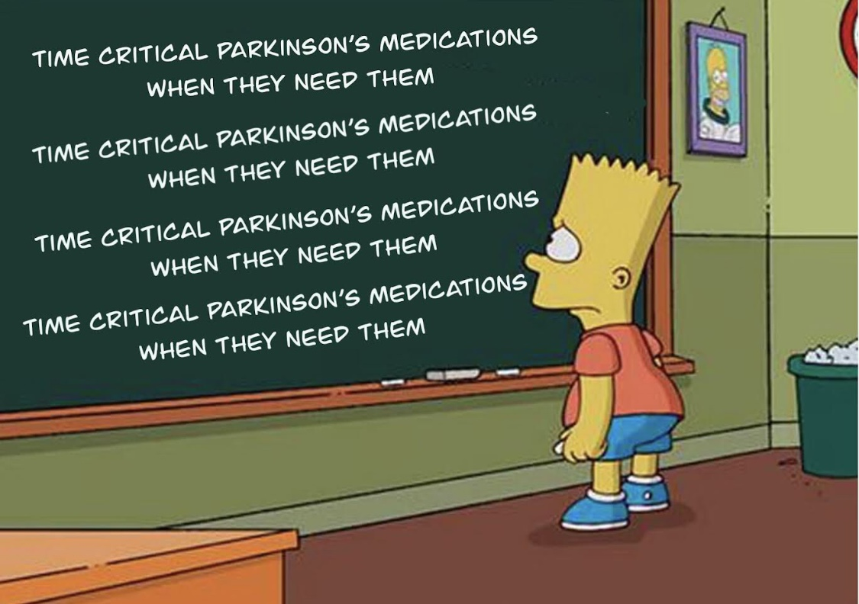
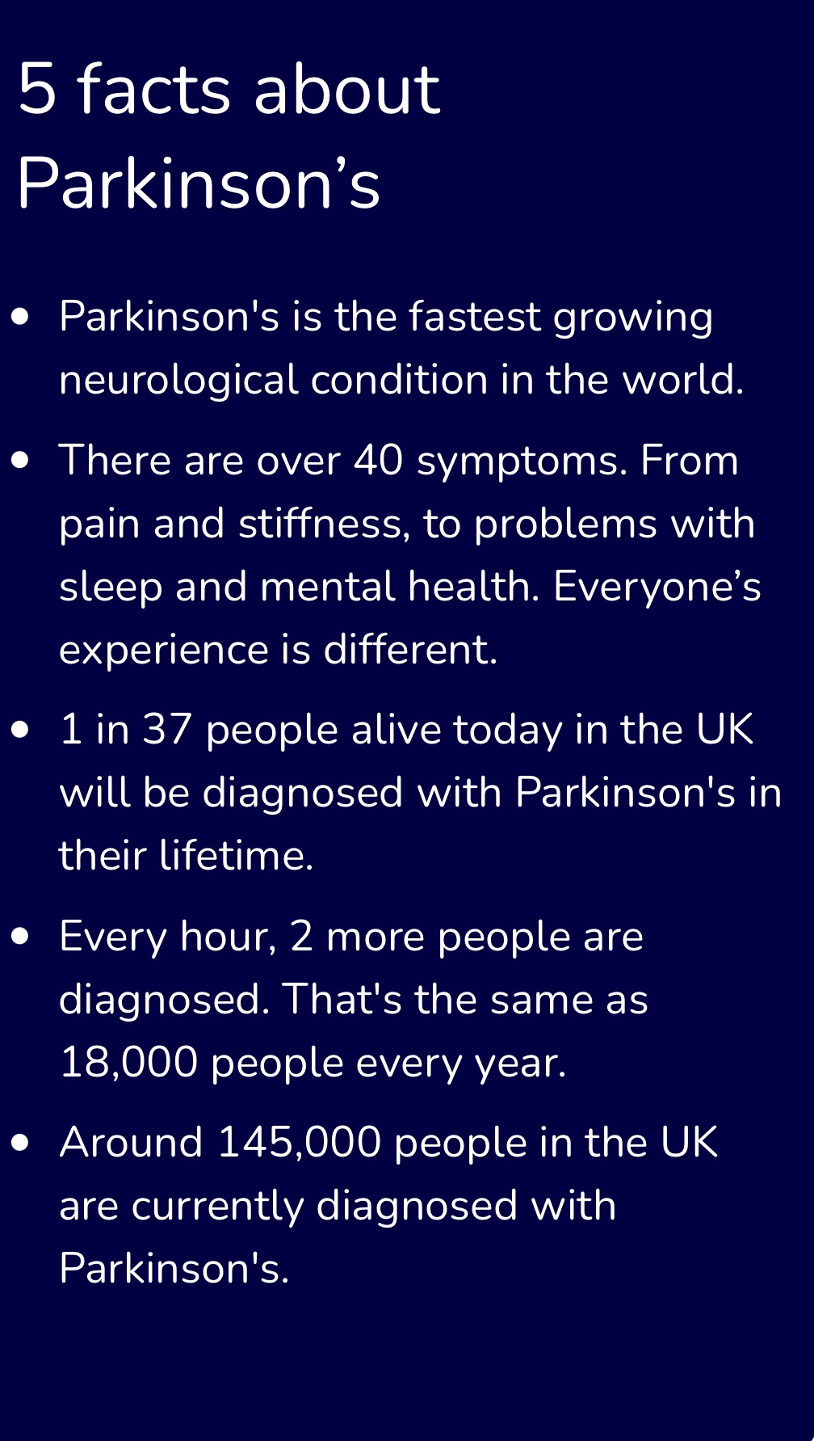
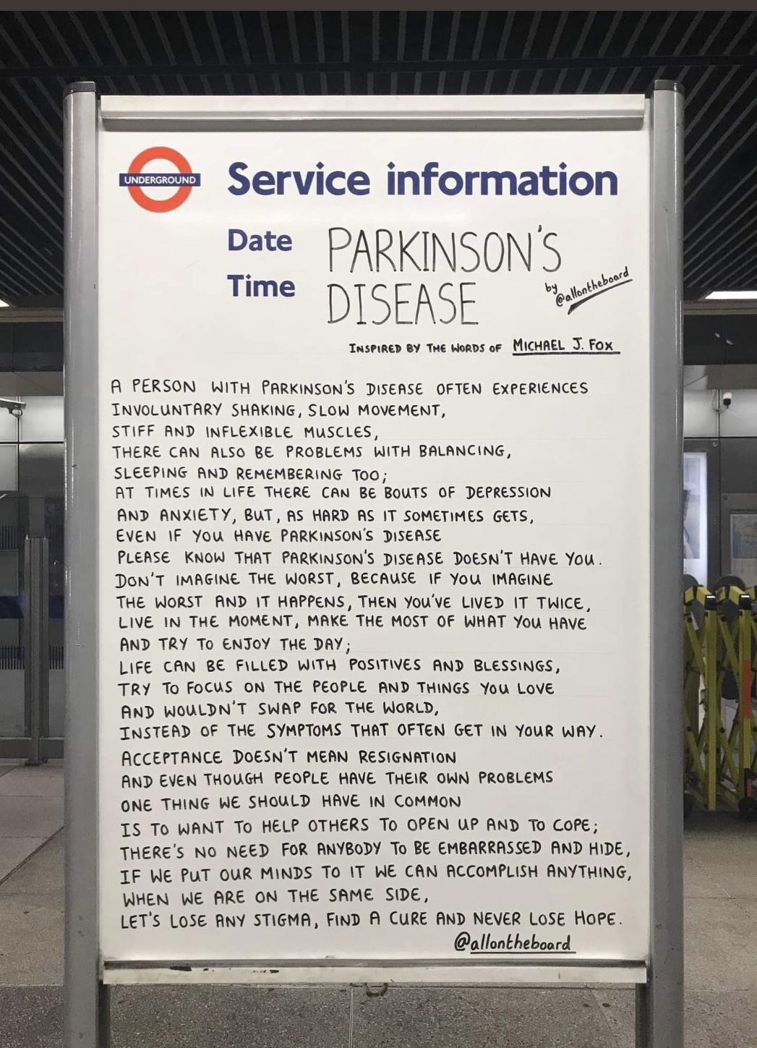

IMPORTANT - KEEPING IN CONTACT
If there is one thing which we have all learnt during the current Covid pandemic, it is the importance of keeping in contact with family and friends.
That ability to maintain contact is something which the Branch Committee feel is vital at any time, but even more so today, as it tries to provide up to date information and support to our members.
The Parkinson’s Post enables us to reach all our members and we have increased the number of issues during the pandemic. However, it is not suitable for those events which occur in between publications.
When we need to inform members quickly, we use e-mail, text messaging and Facebook, so it would therefore be helpful to have as many email addresses and mobile telephone numbers as possible.
Our records suggest that we only hold email and mobile numbers for about 50% of our members. We would like to see that number increase.
If you haven’t provided your email or mobile phone number and you would like to receive notification of new events and information, then please contact me at npdent@aol.com with your contact details.
Many thanks, Nick Dent.
BRANCH TEXT MESSAGING SERVICE.

The Branch have a Text Message reminder service sending out reminders of upcoming events to our members free of charge. We will also use this service where appropriate to inform members of any important pieces of information during the present crisis. If you would like to receive this service, then you just need to take a few minutes to register.

Just text your NAME, MOBILE PHONE NUMBER and YES to 07768146835. If you would prefer us to send the text messages to a friend, family member or carer on your behalf then just add FOR and the NAME to your text message request to join. If you believe you have already registered but haven’t been receiving any messages could you, please resubmit your details to the above number and in addition to the requested information just include PROBLEM

Counselling at the Neuro Therapy Centre

Glesni is the Counsellor at the Neuro Therapy Centre.
Counselling and support sessions include:
Counselling Support
Counselling is offered over the phone or in person.
Listening Service
Contact and support over the phone with trained volunteers.
Gab & Go
A weekly discussion group facilitated by our counsellor Glesni, where you can share thoughts, coping strategies and support. If you'd like to join in, we now have a limited number of places available for in-Centre attendance to join our regular attendees and also the option to join over Zoom too. Tuesdays 12.00 to 13.00 Book a place.

Parkinson's support group

Join our counsellor, Glesni, on Zoom for our Parkinson's Support Group. This has been created after feedback from members and will be a chance for people to share their experience, problems and advice.

Next session: Thursday 21st July 11.30am - 12.30pm, booking is essential.
The groups are free to attend, but if you would like to support our services, you can make a donation, thank you.
To book a place on any support session please call 01244 678619 or email reception@neurotherapycentre.org. Some services can be booked online.

Events and Information.

Monday Choir. Monday 3 – 4. Contact Alison Richards 07899 726859 or thecommunitysingingcompany@gmail.com More information in the link below.
https://localsupport.parkinsons.org.uk/activity/online-social-singalong

Pam’s People – Zoom chat every Thursday at 5pm, contact Pam for joining details. Also see the link below
https://localsupport.parkinsons.org.uk/activity/chester-branch-zoom

Movers Shakers – Every Friday 1.00 – 2.30, contact Liz for details.

Branch Text Message Service – contact Nick to join the system.

Contact information; if you would like to receive the Parkinson Post and other information by email and haven’t already give us authority please contact any of the committee.

Free IT Support at Home see link below.
https://abilitynet.org.uk/at-home/request-free-it-support-home

Parkinson’s UK Helpline – 0800 800 0303
https://www.parkinsons.org.uk/

Parkinson’s and Coronavirus – See the link below for the latest guidance.
https://www.parkinsons.org.uk/news/understanding-coronavirus-and-parkinsons

Branch Membership – If you know anyone who has Parkinson’s or is caring for someone with Parkinson’s or would just like to join, please encourage them to get in touch with any of the committee, thanks.
Terrified by technology? Ignorant about iPads? Confused by computers? Don't be. Just give the friendly team at AbilityNet a call and we'll arrange for one of our local volunteers to give you a call and we can help you make more sense of your technology and how to get the best from it. We're open from 9-5 weekdays and we can be contacted on 0800 048 7642 and we'll see how we can help you out.

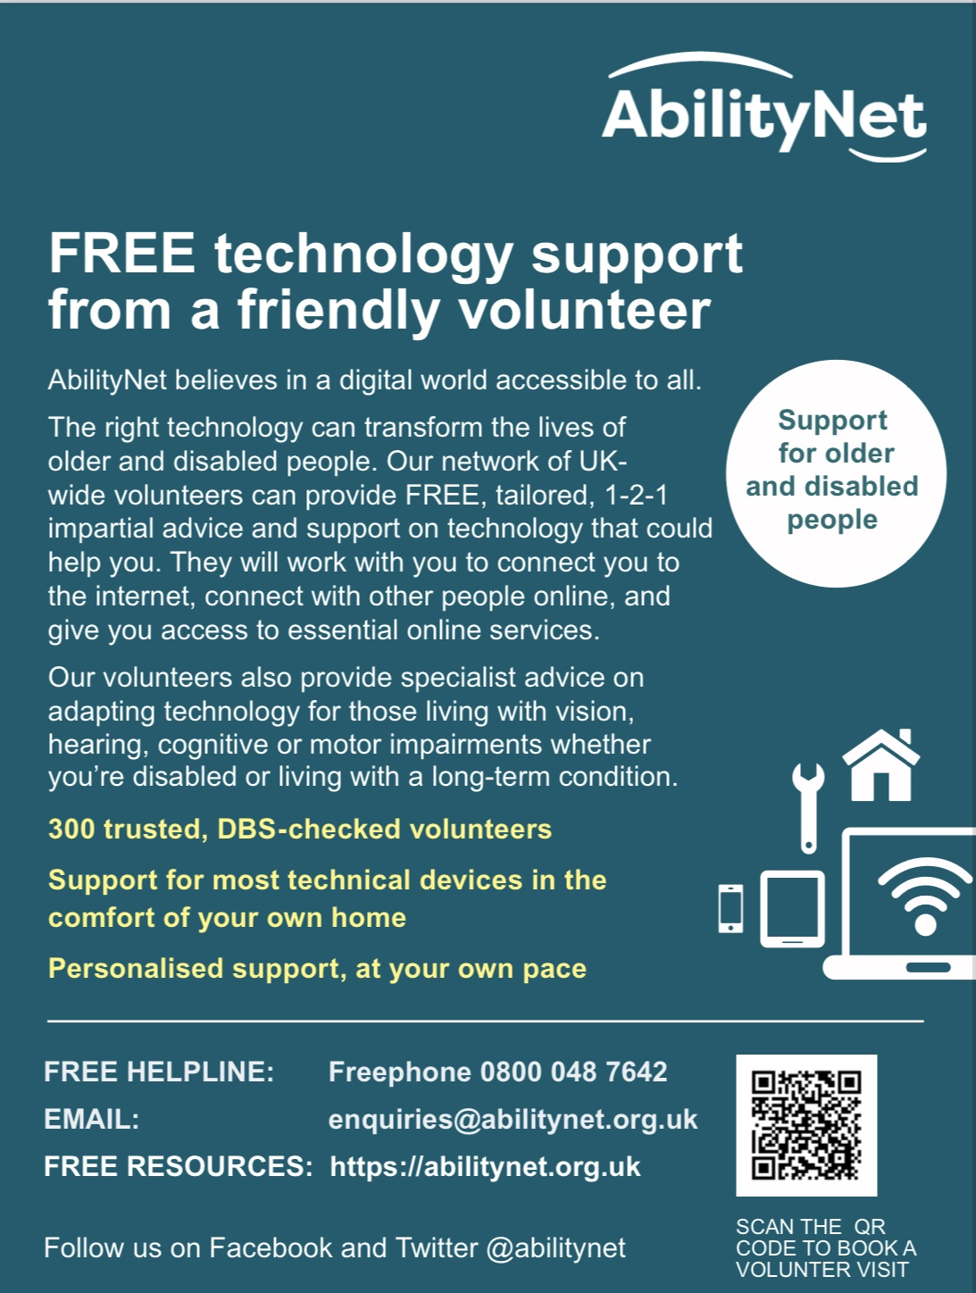

http://prksn.uk/3LtAC1g

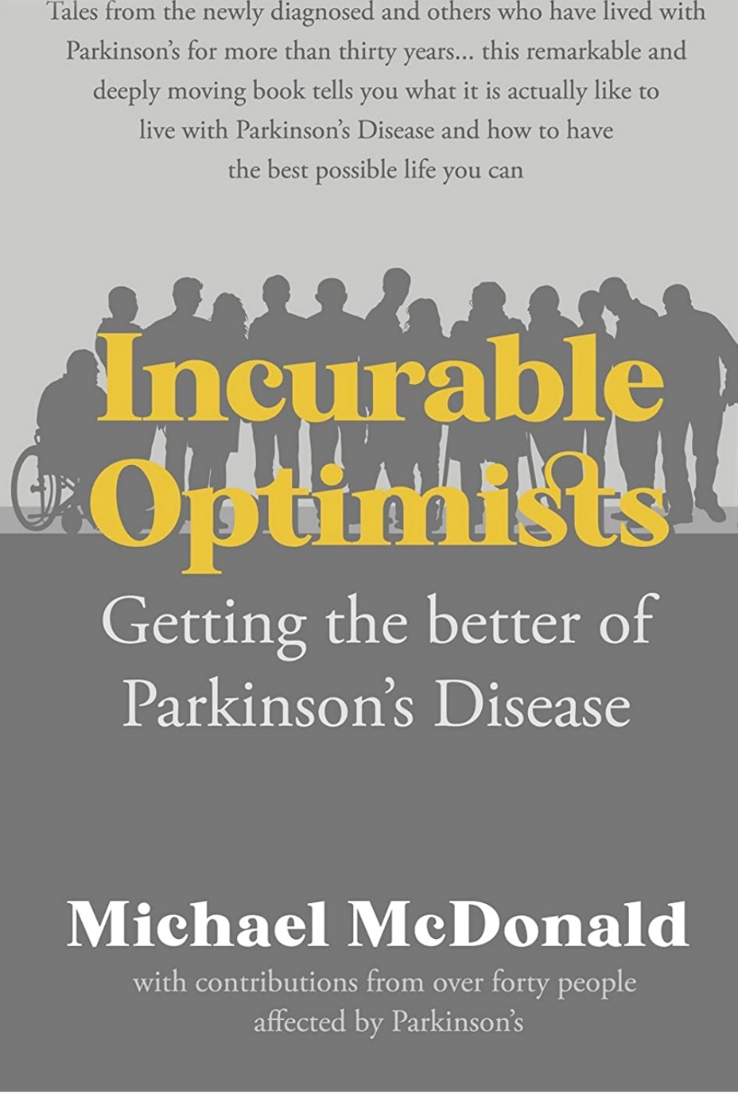

This book, ‘Incurable Optimists’, may be the only book that will tell you what it is actually like to live with Parkinson’s disease.

Written by people whose lives have been impacted by Parkinson’s, these true tales are valuable examples of how one can live one’s best possible life with this difficult condition. The tales are from those newly diagnosed and from others who have lived with Parkinson’s for more than thirty years.
Michael McDonald, who lived in Chester, recognised the pressing need for this book during Zoom sessions with the Parkinson’s group in Canterbury, UK.
The members of the group had all met previously at various therapy sessions, but they had never told their stories to each other or shared their personal challenges and solutions. As soon as they did, and word got around, many other helpful tales began arriving from all over the world.

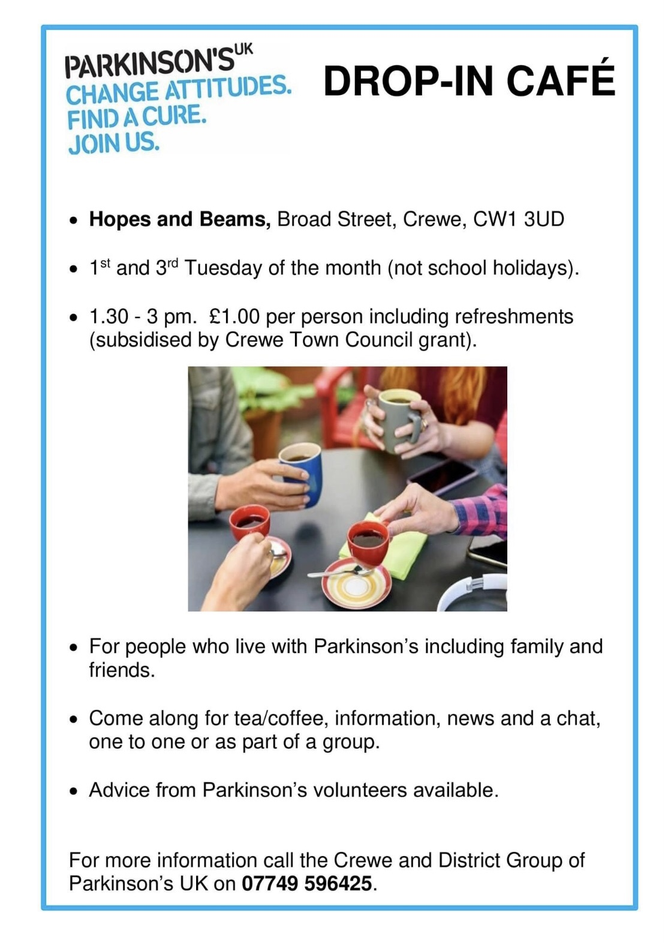

Privacy Policy – Chester & District Branch

We are committed to protecting and respecting your privacy. For any personal data you provide for the purposes of your membership, Parkinson’s UK is the ‘data controller’ and is responsible for storing and otherwise processing that data in a fair, lawful, secure and transparent way. The full version of Parkinson’s UK’s Privacy Policy is available on the Parkinson’s UK website (www.parkinsons.org.uk/about-us/privacy-policy).

You can contact the data protection officer at dataprotection@parkinsons.org.uk or in writing at Parkinson’s UK, 215 Vauxhall Bridge Road, Pimlico, London SW1V 1EJ.

You can also raise any concerns with the Information Commissioner’s Office, contact details for which are at https://ico.org.uk/global/contact-us/.

What personal data we hold on you
You may give us information about yourself when filling in membership forms at an event or online, emailing, phoning, corresponding with us or otherwise. This includes information you provide when you register with the local group, subscribe to our newsletter (Parkinson’s Post) and/or join our singing group. The information you give us may include your name, address, email address and phone number.

Why we need your personal data
The reason we need your data is to be able to provide the membership services you are signing up to when you register with the local group. Our lawful basis for processing this data is that it is in the legitimate interests of the local group and its members. We will use the data only in the ways you would expect – to run the group and support its aims.

Our lawful basis for sending you marketing by electronic means is your consent.

Reasons we need to process your data include:

For membership and management

- processing of membership forms and payments
- sharing data with lead volunteers to provide information about local group activities, membership renewals or invitation to activities and events
- local group newsletter promoting charity activity

Marketing and communications (where separate consent is provided)

- sending information about fundraising and promotions

On occasion, we may collect personal data from non-members (eg any non-member participant who fills in a health disclaimer or carer). Our lawful basis for processing data is consent. We will ask for consent at the point of collecting it.

Where we have social media pages, all members are free to join these pages. If you join one of the Social Media pages, please note that provider of the social media platform(s) have their own privacy policies and the local group does not accept any responsibility or liability for these policies. Please check these policies before you submit any personal data on the social media pages.

Who we share your personal data with
We may need to supply your personal data as part of event administration. There are formal contracts in place that ensure this processing is compliant. If we transfer your personal data overseas to process it, we do so with appropriate safeguards in place to ensure the security of your personal data.

How long we hold your personal data
We will hold your personal data on file for as long as you are a member with us. Any personal data we hold on you will be securely destroyed after one year of inactivity on your part, in line with Parkinson’s UK’s data retention policy. Your data is not processed for any purposes other than those detailed in this policy.

Your rights regarding your personal data

As a ‘data subject’, you may have the right – at any time:

- to request access to, rectification or erasure of your personal data
- to restrict or object to certain kinds of processing of your personal data, including direct marketing
- to the portability of your personal data and to complain to the UK’s data protection supervisory authority, the Information Commissioner’s Office, about the processing of your personal data.
If you wish to exercise any of your rights, you can contact the data protection officer at dataprotection@parkinsons.org.uk or in writing at Parkinson’s UK, 215 Vauxhall Bridge Road, Pimlico, London SW1V 1EJ.

Updated: 17th June 2022.

Other Contacts

For information and resources from Parkinson's UK visit www.parkinsons.org.uk

For advice, emotional support or to access the Parkinson's Adviser service, contact the Parkinson’s UK Helpline, available Monday to Friday: 9am to 6pm, Saturday: 10am to 2pm on 0808 800 0303 or by emailing hello@parkinsons.org.uk

The Walton Centre Nurse Advice Line is 0151 556 4008

Spring Lunch April 2022.

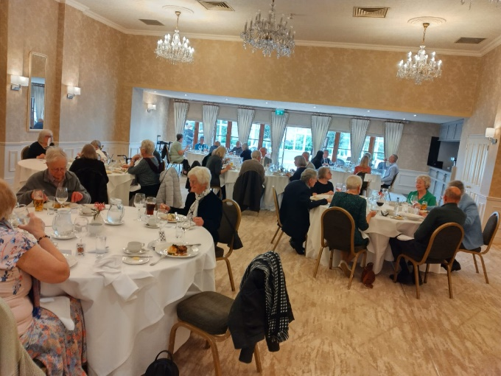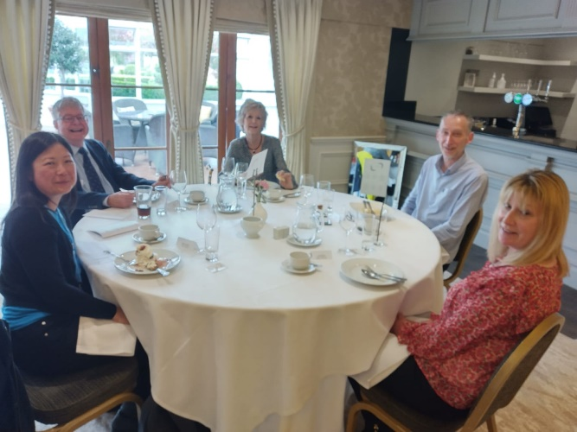

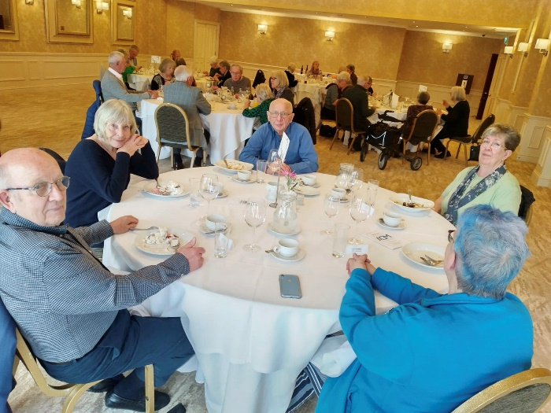
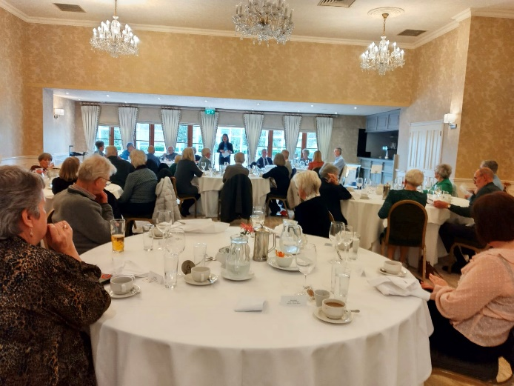
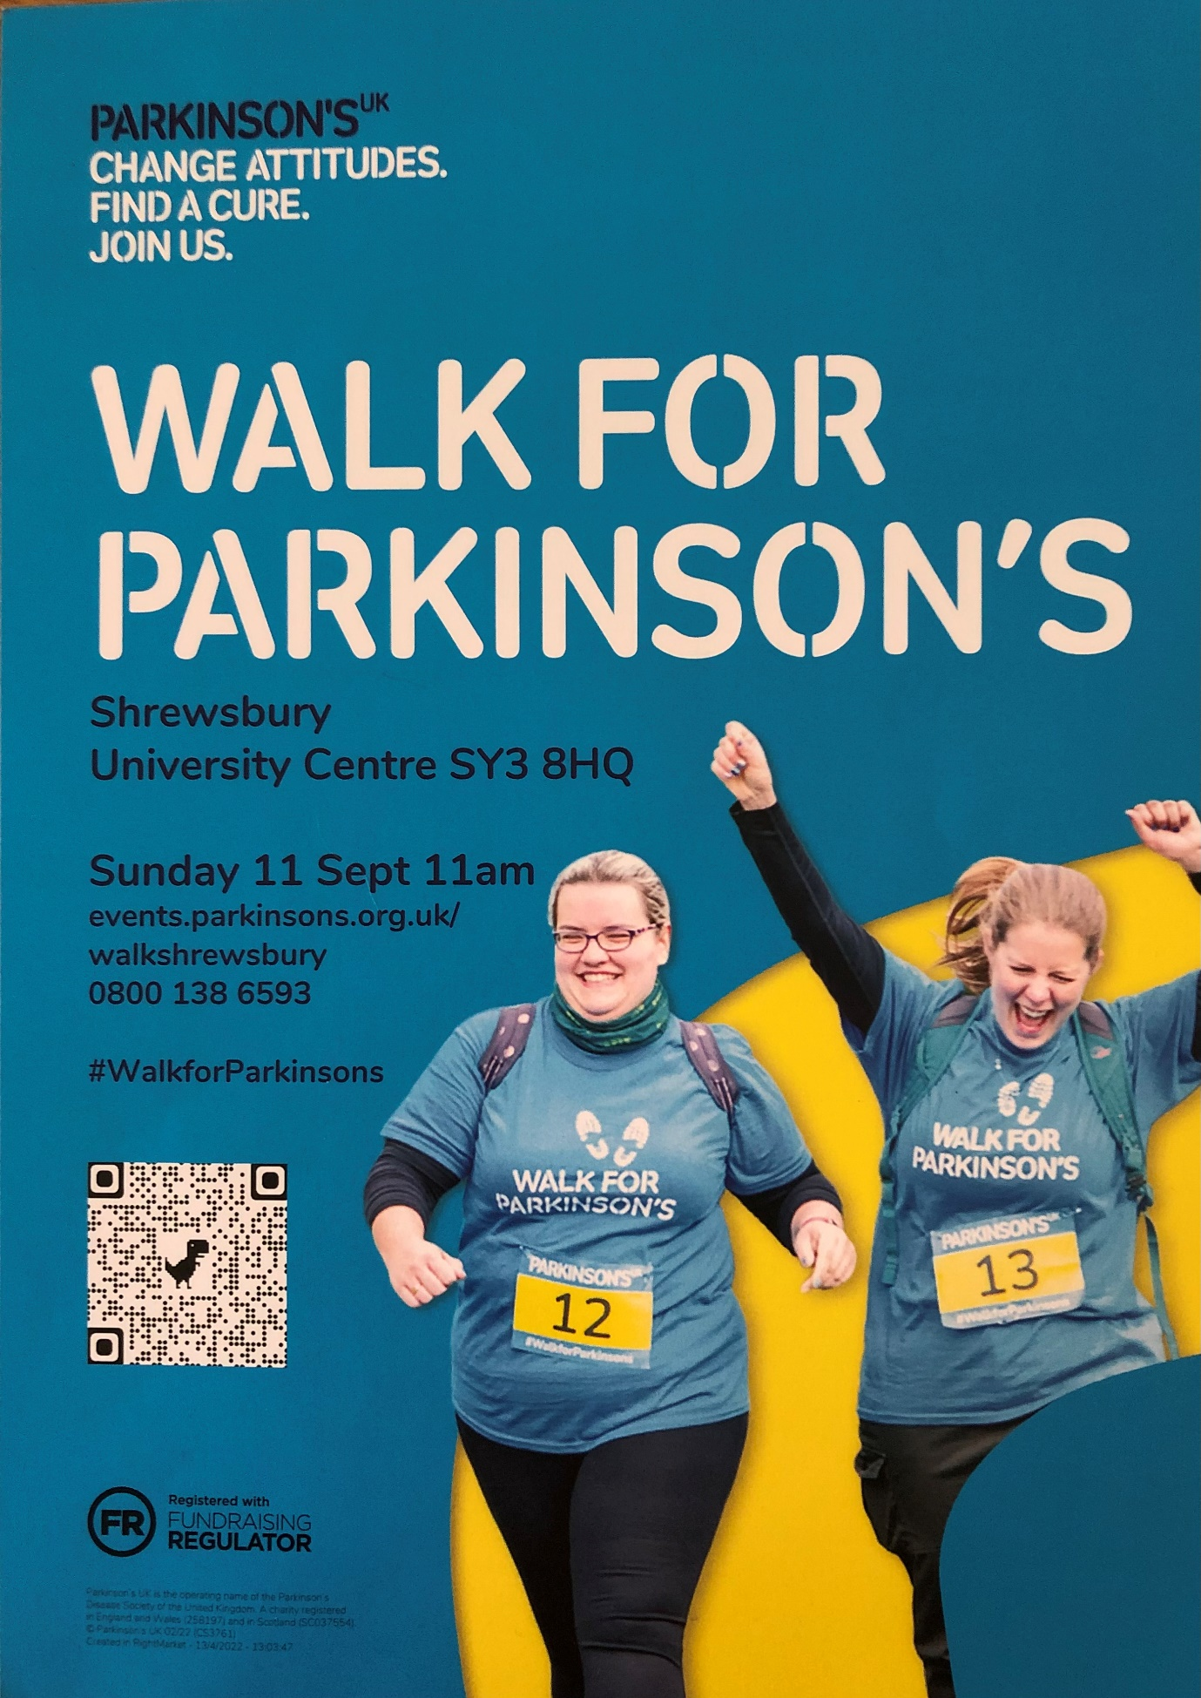
Contacts.

Chairman Vice Chair
Nick Dent Pat Riddell
01244 301378 patriddell31@aol.com

Secretary Membership
Alistair Tranter David Stoddart
01244 311402 01244 316534

Social Secretary Choir
Pam Adams Liz McClure
01244 376546 01244 409414

Treasurer Parkinson’s Post
Ron Welsh Chris Knight
07771633621 chrisknight1@hotmail.co.uk

Mel Stevens:
melshcc@sky.com

﻿Chester & District Branch Parkinson's UK
c/o The Bluecoat Charity,
The Bluecoat,
Upper Northgate Street,
Chester
CH1 4EE.

